**MORGAN COUNTY FAIR**

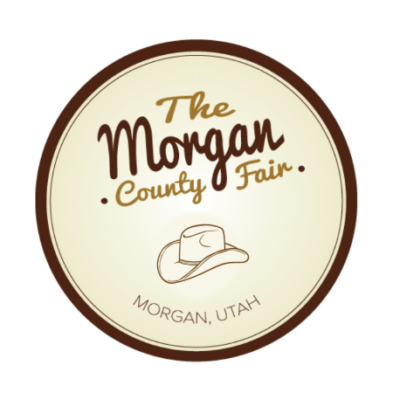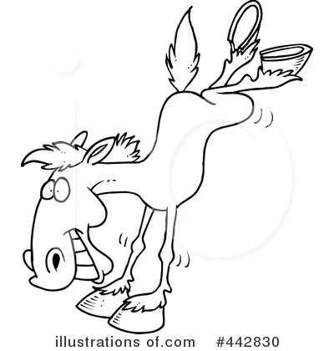

**2nd Wrangler Packet**

**WRANGLERS**

**WRANGLERS**

**AREAS OF WRANGLER COMPETITION**

This is a summary of expectations and what the judges will be looking for in each category of the competition.

APPEARANCE: Hats should be of Western style. Hair and facial hair should be clean cut and nails should be trimmed and free of dirt. Jeans, shirt, belt and boots should be Western style, clean and neat. Horse should be groomed and tach should be clean and presentable.

PERSONALITY: Judges will be looking for your ability to have a conversation on varied and random topics. Things they may look for are grammar, sense of humor, consideration for others and your general outlook on life.

HORSEMANSHIP: You will be judged on how well you sit the horse, your hand and body position, and your ability to control the horse through completion of the pattern/obstacles. You will also be evaluated on how you handle your horse as situations arise. A copy of the horsemanship pattern is included in the contestant packet. Obstacles will vary by age group and may consist of the following: ground tie, pick up foot, rope steer head, drag steer (Head Wrangler and 1st Wrangler only), open and/or close a gate, penning steers.

SPEECH: The speech can be on any topic and must be between two and three minutes in length. You will be judged on composure, creativity, and presentation.

IMPROMPTU Questions will vary and judges will be looking for quick thinking and

QUESTION: creativity.

INTERVIEW: You can expect questions on general horse and tack knowledge, rodeo events, current events and even your personal goals.

WRITTEN TEST: There will be a 25 question written test. The questions will range from Morgan County Fair trivia to general horse, tack, and rodeo questions.

OBLIGATION OF The Wranglers will act as hosts for the entire Morgan County Fair. They

WRANGLERS: will represent the Fair, greet and be friendly to attendees. They will be present during most of the Fair events and may be asked to help with those events. They will be required to participate in the Fair parade and rodeos.

WRANGLER CONTEST RULES

* Contestants must conduct themselves in a gentleman-like manner and portray high moral standards.
* Each contestant will be required to pay a $25 entrance fee. Contestants must read the rules of the Morgan County Fair Wrangler Contest ad sign the official application.
* Each contestant will supply a color photo for the contestant announcement. Photo should be head and shoulder pose. Photo and application must be submitted by July 15, 2021.
* Clothing can be any color but all clothing must be western style.
* Contestants will be required to participate in all areas of the wrangler competition.
* Contestants must provide a horse and the tack necessary to complete the horsemanship competition.
* A contestant or any individual with the intent to influence or harass may not approach the judges or the committee before or after the event. Action of this type will be reported to the Wrangler committee and could result in disqualification.
* The Wrangler Contest Committee shall have the right to publish or cause the publication in any media and use, in any manner, the name, basic biographical background and photograph of each contestant for the purpose of the promotion of the Wrangler Contest and the Morgan County Fair.
* Current Wranglers not participating at required events may be removed from their position and required to pass all prizes/gifts to an alternate for the remainder of the reign.
* If the contestant is under age 18, a parent or guardian is also required to sign the application.

Tips for success

* RELAX-Breathe deep, think of something funny. Visualize yourself as a winner.
* PREPARE-Organize your talk (introduction, body, conclusion). Practice in front of family. Use original material. Make the topic fit you.
* KEEP YOUR TALK UNIFIED-Decide what you want to say and focus on that. All details should relate to your topic.
* PAY ATTENTION TO YOUR DELIVERY-Speak relatively slowly, enunciate clearly and relevant humor.
* APPEARANCE-Keep your posture, limit hand gestures and use eye to eye contact. No gum or candy.

Study suggestions

* HORSE KNOWLEDGE-Know about your horse and tack. Including common ailments and treatment. Study horse magazines, look up horse and tack information on the internet and other related publications.
* RODEO- Visit [www.prorodeo.com](http://www.prorodeo.com), Study the rodeo events, rodeo lingo, and current champions.
* MORGAN COUNTY FAIR-study the fair book or website morgancountyfair.org
* YOURSELF-Favorite color, hobby, horse, food, rodeo event, etc.

Study Samples

Rodeo

PRCA-Pro Rodeo Cowboys Association

ROUGHSTOCK EVENTS-Bareback, Saddle Bronc, Bull Riding

TIMED EVENTS- Steer Wrestling, Team Roping, Tie Down Roping, Barrel Racing, and Team Roping.

BARRIER-A line across the opening of the box that the contestant and horse cannot cross until the calf or steer gets a head start.

ALL AROUND COWBOY-Cowboy who wins the most prize money in a year while competing in at least two events.

BULLFIGHTER-An athlete who protects the bull rider after he dismounts or is bucked off by distracting the bull.

RE-RIDE- If a cowboy’s score is affected by equipment failure, or a horse or bull that doesn’t buck to performance standards, the judges may offer the cowboy a new ride on a different horse or bull.

RANK-Describes especially challenging rough stock.

HOOEY-The knot used to finish tying the calf’s legs together in a tie-down roping.

SLACK-Excess entries that may be scheduled either before or after the rodeo.

MARK OUT-In the bareback and saddle bronc riding, a cowboy’s feet must be above the point of the horse’s shoulders when the horse’s front feet hit the ground – if so, he “marked the horse out,” but if not, he “miss him out” and the ride is disqualified.

CROSSFIRE PENALTY-In team roping, if the header doesn’t change the direction of the steer before the heeler catches, the run is disqualified.

HAZER- In steer wrestling, the cowboy who rides on the right side of the steer from the contestant to make sure the steer runs straight.

HUNG UP-When a bull rider or bareback rider cannot remove his hand from the rope of handle before he dismounts or is thrown off the bull’s or horse’s back.

PENALTY-In timed events, common penalties include 10 seconds for breaking the barrier and, in team roping 5 seconds for a one-hind-leg catch.

Horse and horse health

COLIC-Abdominal pain in a horse.

FOUNDER-Inflammation in the hoof of the horse.

FETLOCK-Another word for the horse’s ankle

POLL-The area immediately behind the ears. This area has nerve and acupressure points.

CROUP-The area from the highest point of the hindquarters to the top of the tail. Also called the rump.

POMMEL- The back of the seat of the saddle.

CANTLE-The back of the seat of a saddle.

BROWBAND-The browband runs from just under one ear of the horse, across the forehead, to just under the other ear. It prevents the bridle from sliding behind the poll onto the upper neck.

THROATLATCH-Runs from the horse’s right ear, under the house’s throatlatch and attaches below the left ear. The main purpose of the throatlatch is to prevent the bridle from coming off over the horse’s head.

SNAFFLE BIT-A bit that is “broken” in the middle with a ring on either side.

HAND- The unit of measure used to measure a horse (4 inches).

FROG- A triangular shape area on the bottom of the hoof that is used as a shock absorber for the leg and also helps pump blood back up the leg.

REGULAR VETERINARY CARE-Teeth vaccinations, hoof care, common illness, and treatment, etc.

Contest events

HORSEMANSHIP * WRITTEN TEST * SPEECH * IMPROMPTU QUESTIONS * PERSONAL INTERVIEW

CONTEST SCHEDULE

AUGUST 3RD, 2021

MORGAN COUNTY FAIRGROUNDS

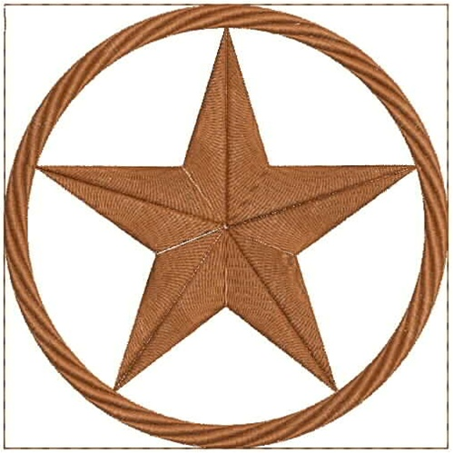

TEST

10:00AM FAIRGOUNDS CONCESSION BOWERY



HORSEMANSHIP

10:30AM FAIRGOUNDS ARENA



LUNCHEON

12:00 PM FAIRGOUNDS CONCESSION BOWERY



INTRODUCTION OF CONTESTANTS, SPEECH, INTERVIEWS

1:00PM FAIRGROUNDS CONCESSION BOWERY



AWARDS CEREMONY

For more information, call

Jessie Franich 801-829-6751

Deadline for entering is July 19, 2021

Clinic will be held on July 29, 2021

