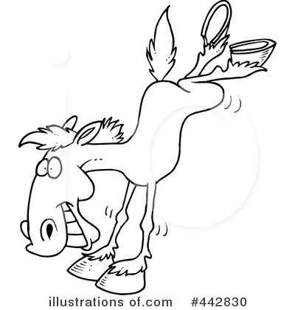
MORGAN COUNTY FAIR
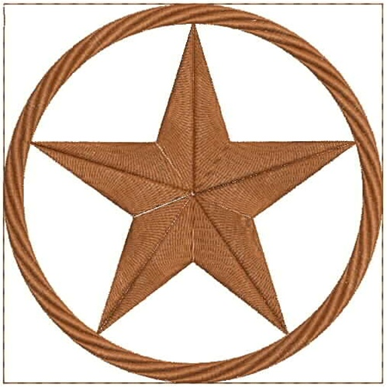WRANGLERS

CONTESTANT INFORMATION

Name:_______________________________________________Age as of July 1, 2021____________________________
Street Address:________________________________________City:________________State:_________Zip__________
Phone:_______________________________________________Parents:_______________________________________
Email:

Categories: Circle one

Head Wrangles 1st Wrangler 2nd Wrangler
(13-18 Years of age) (10-12 Years of age) (7-9 Years of age)

Tell us why you would like to be the Morgan County Fair Wrangler:___________________________________________
____________________________________________________________________________________________________________________________________________________________________________________________________________________________________________________________________________________________________________________________________________________________________________________________________________________________________________________________________________________________________________________________________________________________________________________________________________

Provide an introduction of yourself. Include hobbies, talents, goals, etc:________________________________________
______________________________________________________________________________________________________________________________________________________________________________________________________________________________________________________________________________________________________________________________________________________________________________________________________________________________________________________________________________________________________________________________________________________________________________________________________________________________________________________________________________________________________________

By submitting this application, I attest that the facts set forth in it are true and complete. I understand that if I am accepted as a Contestant in the Morgan County Fair Wrangler Contest, any false statements, omissions, or other misrepresentations made by me on this application may result in disqualification.

Contestant Signature:_____________________________________________________Date:_______________________
Parent/Legal Guardian Signature:____________________________________________Date:_______________________

Morgan County Fair-July 31-Aug 7, 2021
Application and Fee Deadline: July 19, 2021
$25 Application Fee (Make checks payable to Morgan County Fair)
Return application and fee to Jesse Franich

